|  |  |  |
| --- | --- | --- |
| **Applied Physics (NS-1001)**  Date: March 26th , 2024  **Course Instructor**  **Semester:** SP-2024  **Dept:** School of Computing |  | **Sessional-I Exam**  **Total Time: 1 Hour**  **Total Marks: 30**  **Total Questions**: 04  **Campus:** Karachi |

____________________________ ______________ _____________________

Student Name Roll No Section Student Signature

# CLO # 1 Vectors

**Q1: Answer the following: [08]**

1. A centripetal-acceleration addict rides in uniform circular motion with radius r=3 m. At one instant his acceleration is a=(600m/s2)i +(−4m/s2)j​.

At that instant, what are the values of (a) v**.**a and (b) r**.**a  [3]

1. The three vectors in Fig-1 have magnitudes a = 4 m, b = 6 m, and c = 12 m and

angle θ = 30°. Find the resultant vector, magnitude of resultant vector, and angle. [3]

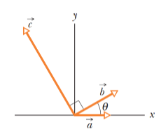**Fig-1**

1. Find the area of the parallelogram with adjacent sides **A =** 3**i** - 2**j +** 4**k** and **B =** -**i** - 4**j +** 2**k. .** [2]

# CLO # 2 Linear Motion

**Q2: Answer the following: [08]**

1. A particle initially has v = 3i−5j+2k and then 4.0 s later has v = -13i−2j+9k (in meters per second). For that 5sec, what are (a) the particle average acceleration aavg in unit vector notation, (b) the magnitude of aavg, and (c) the angle between aavg and the positive direction of the y axis? [2]
2. Point out the two motion characteristics which are true of free-falling objects. [2]

1. Fig-2 depicts the motion of a particle moving along an *x* axis with a constant acceleration. The figure’s vertical scaling is set by *xs=7.5*0 m. What are the (a) magnitude and (b) direction of the particle’s acceleration? [2]
2. With the help of the following Position – time graph, draw velocity versus time (v vs t) and acceleration versus time (a vs t) graphs for Fig-3. [2]

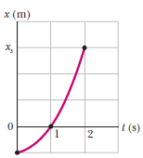. 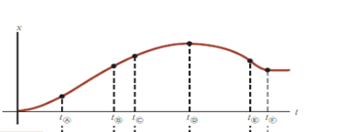

**Fig-2 Fig-3**

# CLO # 3 Projectile Motions

**Q3: Answer the following: [04]**

1. A ball is thrown horizontally from the top of a building that is 20 meters tall. The initial velocity of the ball is 15 m/s. Determine: (i) How long does it take for the ball to hit the ground? (ii) What is the horizontal range of the ball? [4]

# CLO # 4 Forces

**Q4: Answer the following: [10]**

1. Two blocks of mass 5 kg and 9 kg are connected by a string of negligible mass that passes over a frictionless pulley (Fig-5). The inclines are frictionless. Find (a) the magnitude of the acceleration of each block and (b) the tension in the string. Take g = 10 ms-2. [5]

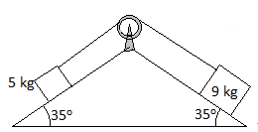 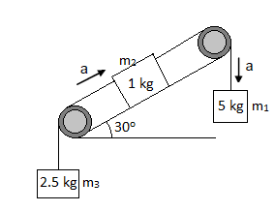

**Fig-5 Fig-6**

1. Draw a free body diagram for Fig-6 and write down the equation of Forces. The incline has friction. [3]
2. In team sports like football or soccer, how can players apply Newton's laws to optimize their movements and strategies during a game? [2]